**4.1. Types of education and its structure**

**LEAD- IN**

**Task 1**. Look at the word cloud below and find different kind of schools and give their definitions.

За

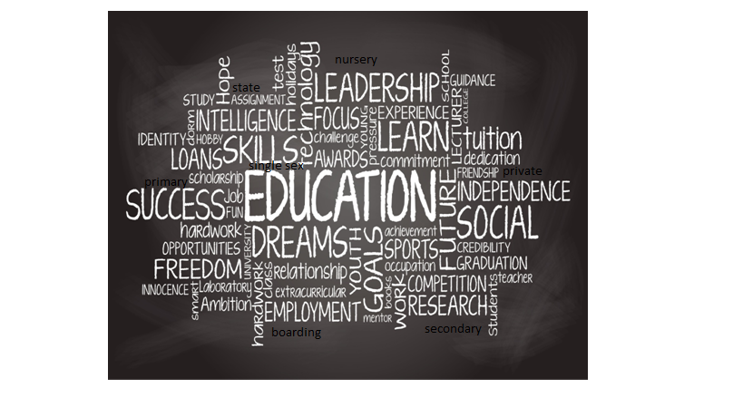

**Education-** is the process of facilitating learning, or the acquisition of knowledge, skills, values, beliefs, and habits. Educational methods include teaching, training, storytelling, discussion and directed research. Education frequently takes place under the guidance of educators, however learners can also educate themselves.

**Dreams**- a succession of images, ideas, emotions, and sensations that usually occur involuntarily in the mind during certain stages of sleep.

**Skills** – is the ability to carry out a task with determined results often within a given amount of time, energy, or both. Skills can only be innate

**Success** – to compete openly with others on one's own, based on one's social status or status, for example, to win in research or market competition. In this sense, the term is the opposite of prefixed status.

**Goals** – a mental manifestation of an action aimed at achieving a certain goal. The goal is the ideal, the inner driving force, which is born by predicting the future as a result of thinking

**Graduation** – is the award of a diploma or academic degree, or the ceremony that is sometimes associated with it, in which students become graduates. The date of graduation is often called graduation day.

**Boarding** – dormitory at the university; closed educational institution. Educators in the boarding school carry out educational work according to the plan approved by the school administration.

**Secondar**y – is an organization that provides secondary education and the building where this takes place.

**Job** – human activity aimed at creating material, spiritual and other values necessary for human life.

**Employment** – employment rate of the able-bodied population in the country.

**Relationship** – a complex process of communication between people, creating the need for interaction; exchange of cognitive or emotional information, experience, knowledge, skills, abilities between two or more people

**Research** – test performed to determine a new phenomenon, sanctity, dependence.

**Task 2**. Compare the given table according to the education system of our country and discuss

|  |  |  |  |
| --- | --- | --- | --- |
| **Age range** | **British Education** | **American Education** | **Kazakh Education** |
| nursery school/ kindergarten | 2-5 ages | 5-6 ages | 2-5ages |
| primary school /elementary school | 5-11 ages | 5-11 ages | 6-11ages |
| secondary school | 11-18 ages | junior high school (11-14 ages)  high school (14-18 ages) | 11-18 ages |
| College /University | 18+ | 18+ | 16-18 ages |

**Task 3.** What types of subjects / sports do you know?

|  |  |
| --- | --- |
| SUBJECTS | TYPES OF SPORT |
| mathematics  biology  chemistry  Kazakh language  English language  physical education  geometry  computer science | football  basketball  volleyball  handball  curling  Kazakh wrestling  Taekwondo  skiing |

**WRITING**

**Task 1.** This is a part of a letter you received from an English pen-friend.

*In your next letter tell me about your school you went to. What kind of school? what teachers were like? Did you like your school: what you liked and didn't like.*

**Dear Arman,**

**How is your family?**

I haven't seen you for a year, I miss you very much.

You asked me about the school I went to, so I decided to write it down. I went to school at Murager in the city of Kyzylorda.

I didn't notice how 11 years passed. In general, my school had good teachers and there were no big problems in education. My school had modern technology, every year students were sent abroad. Although more than 3,000 students studied at our school, everyone knew each other thanks to the school sections and events.

**Write soon and let me know all the news**

**Your friend**

**Zinabdin**